**ENGR 121 Homework 7**

**NOTE:** Use engineering format for problems 1 through 3, and use non-engineering format for problem 4-6. This is an individual assignment.

1. A heater with a mass of 6 grams is used to heat the water in a small tank which has a diameter of 1.5in and water at a depth of 2in. The heater is made of several materials; the average specific heat (or heat capacity) of the heater material is 910 𝑘𝑘𝑘𝑘∙℃𝐽𝐽 . If the heater is turned off when the water reaches a temperature of 22°C (the upper control limit) and the heater has an average temperature of 70°C when it is turned off, then how much would you expect the water temperature to overshoot the upper control limit? Overshoot by 1.06℃

HINT: The heater will continue to transfer energy to the water even after the heater is turned off (since it has a higher temperature than the water). Eventually, the heater and the water will approach the same temperature as the heater cools and the water warms. The decrease in internal energy of the heater will be equal to the increase in internal energy of the water, assuming no heat is lost by heat transfer from the tank (through the PVC or at the surface of the water).

1. You just made a cup (0.3 liters) of coffee, but it is too hot to drink. You wish to decrease the temperature of the tea from 72°C down to 64°C by submerging a number of aluminum spoons into the coffee. However, instead of completely sinking the spoons, you only stick them 3/4 of the way down into the coffee. If the spoons are at room temperature (25°C), then how many spoons will be required to decrease the coffee to the optimum temperature? 5 spoons Assume:
   * + Cp for coffee = 4184 𝑘𝑘𝑘𝑘∙℃𝐽𝐽
     + Cp for aluminum = 921 𝑘𝑘𝑘𝑘∙℃𝐽𝐽
     + density of coffee = 1000 kg/m3
     + no heat loss from the cup
     + mass of one entire spoon = 80 grams
     + only the submerged portion of the spoons will change temperature

1. A baked potato is prepared by adding the butter, cheese, sour cream, and green onions. Estimate the average temperature of the baked potato after preparation using the information provided below, neglecting any heat gains or losses due heat transfer. T2 = 81.8°C

|  |  |  |  |
| --- | --- | --- | --- |
| **ingredient** | **Cp** 𝒌𝒌𝒌𝒌𝑱𝑱∙℃ | **mass**  **g (oz.)** | **Initial Temperature °C (°F)** |
| potato | 3430 | 520 (15.9) | 96 (204.8) |
| cheddar cheese | 2700 | 45 (1.24) | 4 (39.2) |
| butter | 1260 | 30 (0.99) | 3 (37.4) |
| sour cream (or cottage cheese) | 3260 | 35 (1.06) | 2 (35.6) |
| green onions | 3350 | 15 (0.04) | 6 (42.8) |

1. Using the Internet and any other sources, learn about the book “The World is Flat” by Thomas Friedman. Write a paragraph in your own words describing what you have learned); be thinking about the impact that the ideas presented in the book might have on your career. **We expect you to spend between 15 minutes and 30 minutes looking into this issue to provide background for an in-class discussion.**

The modern prospective global outreach gives engineers like me a better chance of getting a stable career in many parts of the world. The benefits brought forward by modern technology allow people to more easily end up on the radar of businesses and enterprises that need to quickly fill up empty positions. Long-range modes of communication like the internet allow for mutual agreements between two parties, whether they be corporations or individuals, in a short period of time. At the same time, certain advanced in what Friedman calls “workflow software” allows corporations to automate certain business-oriented tasks, making more room and demand for STEM-related careers.

1. Turn in your SolidWorks assembly of the Arduino mounted to the aluminum plate. Turn in two screen shots of your SolidWorks drawing(s), one at an intermediate stage (unassembled) and one of the final Arduino and plate assembly. Turn in your hand sketch with your SolidWorks drawings.

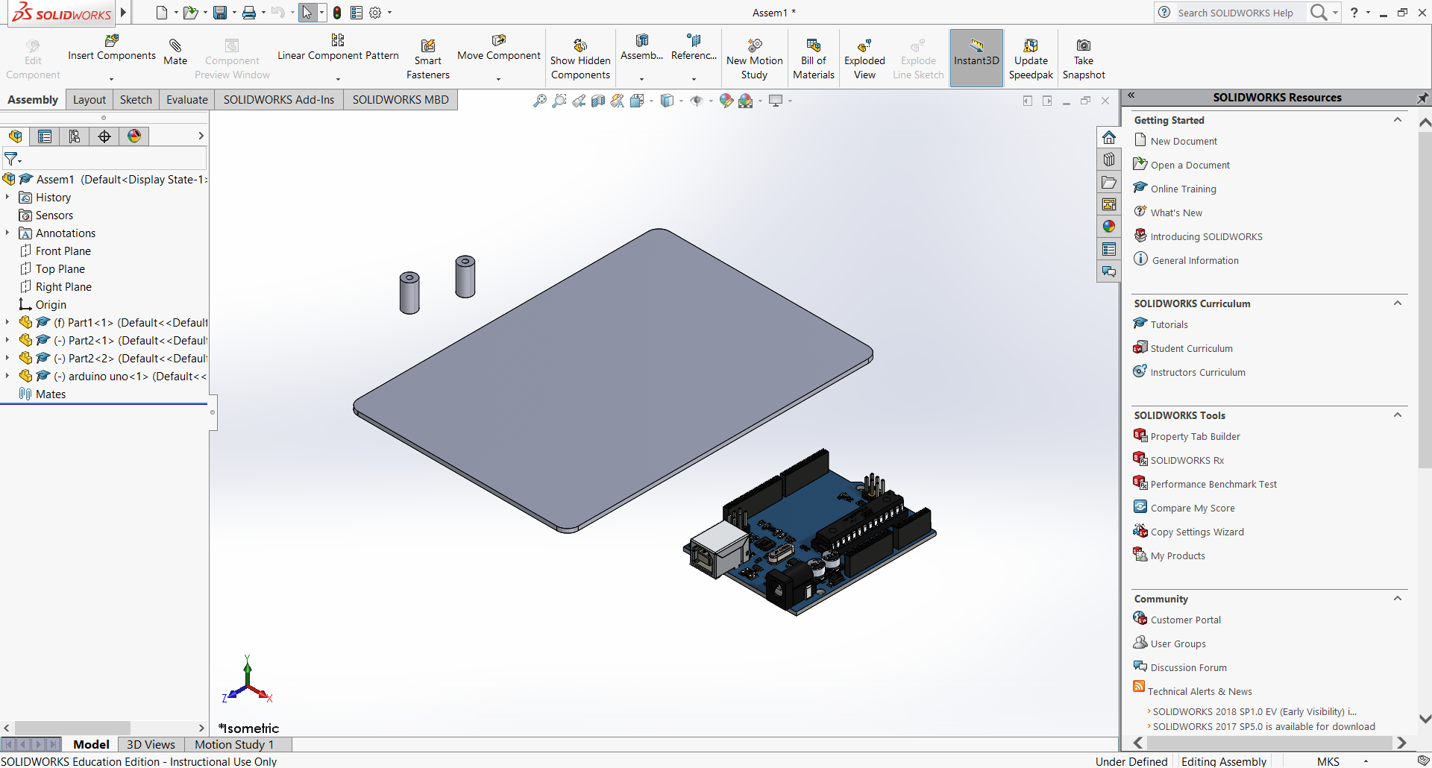

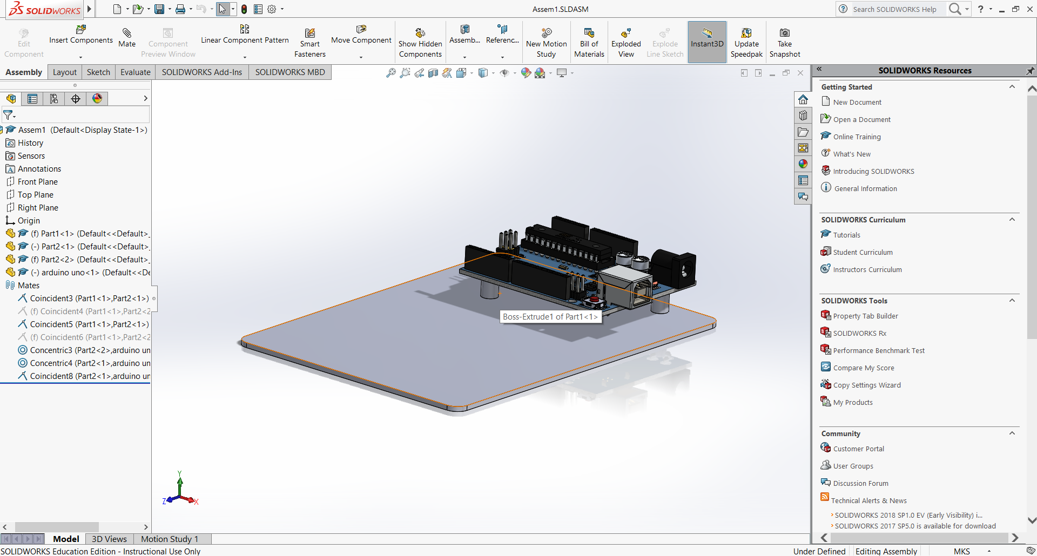

1. Paint your fishtank platform. PLEASE be careful not to damage your room, the parking lot, or any other property by dripping paint. Use plastic bags, cardboard, or some other disposable surface to place under your platform when painting. Have fun and be creative!

1. 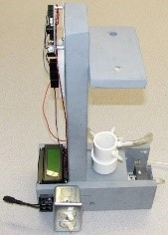**(Due Class 9)** For homework 8, you will combine all of the parts listed below into one assembly. Include images of each individual part and show your SolidWorks final assembly from at least two points of view.

*Parts to be created:*

* + the fishtank reservoir with three fittings (inlet, outlet, overflow)
  + the conductivity sensor with fittings (you don’t have to draw the wires, terminals or tubing)
  + the wooden platform assembly
  + 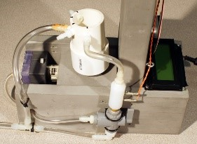the 3-way valve (hand sketch is not required since part file was downloaded)
  + the LCD screen (rough detail of shape is good enough, but use correct measurements)
  + the Arduino (rough detail of shape is good enough, but use correct measurements)
  + the pump (it’s OK to use your pump assembly from ENGR 120)